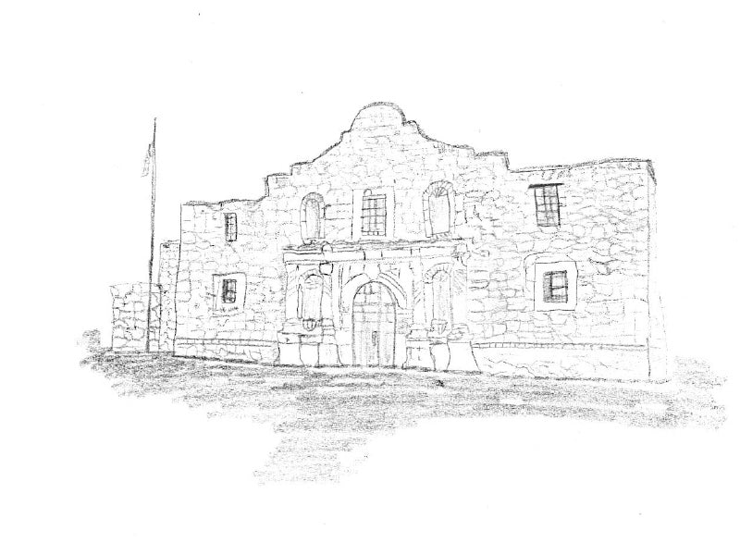
Battle at the Alamo!
A swing brought to you by San Antonio College and Tyler Junior College
Dear Colleagues:
San Antonio College and Tyler Junior College invite you to the Battle at the Alamo, October 17-19, 2025. Both tournaments will be held on the San Antonio College Campus. Tournament staff will use SpeechWire for registration, tournament tabulation and ballot distribution. Competition rooms will be held mainly in McCreless Hall (MCCH)---more information to come closer to the competition. Please see the map at the bottom of the invite for more information. The swing is open to all intercollegiate competitors. The tournament will offer NPDA and IPDA, in addition to all 11 AFA-NST individual events.
On Friday, 4 or 5 rounds of NPDA debate will be offered with quarters (or semis) on Friday as well. Semis (or finals) will be held on Saturday (Semis and Finals may be conducted on Friday, depending on the W-L records on the break)---dependent on tournament entries. There will be only one division offered. We will follow all NPDA rules and procedures. Additionally,4 rounds of IPDA will be offered on Saturday. Competitors in IPDA will not be able to cross-enter in individual events on Saturday. We will follow all Phi Rho Pi IPDA rules and procedures. Saturday and Sunday will each be a self-contained IE tournament, with all 11 AFA-NST Individual Events. There will be only one division offered. We will follow all AFA rules. No prepared event may have been used in competition prior to this academic year.
ENTRIES: Entries will be registered through SpeechWire. Fees will be calculated at 12:00 pm on Tuesday, October 14th. Adds or drops after 5:00 pm on Wednesday, October 15th, are subject to regular fees as assessed on the 15th plus a nuisance fee of $10. There is no limit on the number of students a school may enter per event. Students may enter no more than three events per pattern. Students entered in multiple events are responsible for shifting between events within the prescribed time allotments, and judges will not wait past the scheduled times for students who are delayed due to being cross-entered.
JUDGES: We ask that schools work as hard as they can to provide exceptional judges to cover their events. One judge can cover four (4) individual events slots per pattern for a total of 8 slots across the two patterns. Each debate judge covers two (2) Parli debate teams or two (2) IPDA entries. A very limited number of hired judges will be available for uncovered slots/teams. Note: A judge cannot be counted for both IPDA and Individual Events. For the Saturday portion of the swing, please designate your judges as either an individual event judge or an IPDA judge. The tournament reserves the right to place judges in events they have not been designated to judge in order for the tournament to run on time. NPDA judges are obligated for one round beyond their team’s eliminations. For all other events, judges are obligated through the end of the tournament on each day.
FEES: Debate entry fees for the tournament are $50 per entry. Debate judging fees are $75.00 per uncovered team. One judge covers two debate entries. IE entry fees for the tournament are $10.00 per slot per half. Each judge, as previously mentioned, covers four (4) individual event slots per pattern. Hired judges are an additional $15.00 per uncovered slot. Schools that drop judges after Wednesday, October 15th, at 5:00 PM will incur a $100.00 nuisance fee plus all fees for uncovered slots/teams. Cash is the preferred for payment of fees. If you must pay by check, please make checks for both halves of the tournament payable to M’Liss S. Hindman.Venmo or Zelle payments are accepted. Email mhin@tjc.edu for usernames.

FOOD: Friday, Saturday, and Sunday, there are plenty of fast food options around the campus (Bill Millers, Whataburger, Starbucks, PhiloCoffee, Jimmy Johns, Subway, and many more. In the evenings, the campus is extremely close to the Pearl, Downtown San Antonio, and Southtown for eating and shopping.
We look forward to seeing you here in San Antonio in October!
Respectfully,

Justin Blacklock
Director of Forensics
San Antonio College
M’Liss S. Hindman
Director of Forensics
Tyler Junior College

2025 Battle at the Alamo!

Tentative Debate Schedule

Friday
11:00 am Tournament Check In (Oppenheimer Classroom Building)
11:40 am Rd 1 Topic Announce
12:00 pm Rd 1 NPDA
1:00 pm Rd 2 Topic Announce
1:20 pm Rd 2 NPDA
2:20 pm Rd 3 Topic Announce
2:40 pm Rd 3 NPDA
3:40 pm Rd 4 Topic Announce
4:00 pm Rd 4 NPDA
5:15 pm Finals Topic Announce
5:35 pm NPDA Finals

Get some rest and we will see you Saturday morning!

Saturday*
7:00 am IE Registration (Nursing Allied Health Complex)
7:30 am Draw (Flight A IPDA)
8:00 am Rd 1 (Flight A IPDA),
Draw (Flight B IPDA)
8:30 am Rd 1 (Flight B IPDA)
9:30 am Draw (Flight A IPDA)
10:00 am Rd 2 (Flight A IPDA,)
Draw (Flight B IPDA)
10:30 am Rd 2 (Flight B IPDA)
11:00 am Draw (Flight A IPDA)
11:30 am Rd 3 (Flight A IPDA)
Draw (Flight B IPDA)
12:00 pm Rd 3 (Flight B IPDA)
12:30 pm Lunch Break
1:00 pm Draw (Flight A IPDA)
1:30 pm Rd 4 (Flight A IPDA,)
Draw (Flight B IPDA)
2:00 pm Rd 4 (Flight B IPDA)
3:00 pm Draw (IPDA)
3:30 pm Elim 1 (IPDA)
5:00 pm Draw (IPDA)
5:30 pm Elim 2 (IPDA) – if necessary
7:00 pm Elim 2 (NPDA) – if necessary
8:15 pm Awards Ceremony
ASAP Elim 3 (DEBATE) - if necessary
* IPDA competitors will not be allowed to enter Pattern A nor B for Saturday’s Tournament.

Tentative IE Schedule

Saturday*
7:00 am IE Registration (Nursing Allied Health Complex)
7:30 am Draw (EXT)
8:00 am Rd 1 (Pattern A**)
9:30 am Rd 1 (Pattern B***)
11:00 am Draw (EXT)
11:30 am Rd 2 (Pattern A)
12:30 pm Lunch Break (on your own)
1:30 pm Rd 2 (Pattern B)
3:00 pm Draw (EXT)
3:30 pm Finals (Pattern A)
5:30 pm Finals (Pattern B)
8:15 pm Awards Ceremony
* IPDA competitors will not be allowed to enter Pattern A nor B for Saturday’s Tournament.
** Pattern A (EXT, POI, PER, DUO, POE, CA)
*** Pattern B (IMP, PRO, INF, DI, ADS)

Sunday
8:00 am Draw (EXT)
8:30 am Rd 1 (Pattern A)
9:45 am Rd 1 (Pattern B)
11:00 am Draw (EXT)
11:30 am Rd 2 (Pattern A)
12:45 pm Lunch Break (on your own)
1:15 pm Rd 2 (Pattern B)
2:30 pm Draw (EXT)
3:00 pm Finals (Pattern A)
4:15 pm Finals (Pattern B)
ASAP Awards Ceremony

IE Sweeps:
1st Place 10 pts
2nd Place 7 pts
3rd Place 5 pts
4th Place 2 pts
5th Place 2 pts
6th Place 2 pts
7th Place 2 pts

DEBATE Sweeps:
Prelim Win 2 pts
Advance to Quarters 2 pts
Advance to Semis 2 pts
Advance to Finals 2 pts

Event Rules for IPDA (Phi Rho Pi National Tournament Rules)

IPDA (International Parliamentary Debate Association)
a. Topics will be announced in-round by the judge with 5 topics (2 value, 2 policy, 1
metaphor) provided for strikes. Negative strikes first, and then turns are
taken until one topic remains to be debated.
b. Debaters will not be allowed to consult any other person during prep
time. Prep IPDA rules, they will be allowed paper and/or electronic
research material, which may be quoted or paraphrased from notes during
the round, but not read directly, as extemporaneous delivery is required.
c. Time limits:
Affirmative Constructive 5 minutes
Cross Examination 2 minutes
Negative Constructive 6 minutes
Cross Examination 2 minutes
First Affirmative Rebuttal 3 minutes
First Negative Rebuttal 5 minutes
Second Affirmative Rebuttal 3 minutes
d. Two minutes Flex time is allowed for each side.

San Antonio College
1819 N. MAIN AVE.
SAN ANTONIO, TEXAS 78212
(Above is the Campus Address---Buildings all over campus are still closed for renovation so we will be on the south side of campus this year in OC- Oppenheimer and NAHC- Nursing Allied Health Complex)
Interactive Map: https://map.concept3d.com/?id=1159#!ct/70342,64482?s/
There are two parking lots next to the building just off Evergreen (very bottom of the map) OR there is plenty of parking in the open garages as well (just a tiny walk).
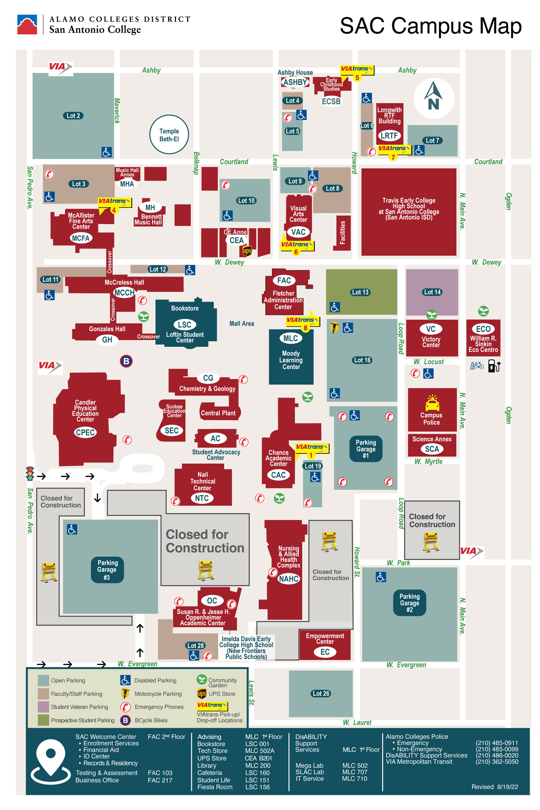

Library
Gymna

